Name: Ali Albayrak

Student ID: P304320

Web Programming Project

To Create a database from excel sheet, I used mysql workbench.

Firstly, I converted excel file(xlsx) to csv from the following link;

<https://convertio.co/tr/xlsx-csv/>

I created a new schema in mysql workbench.

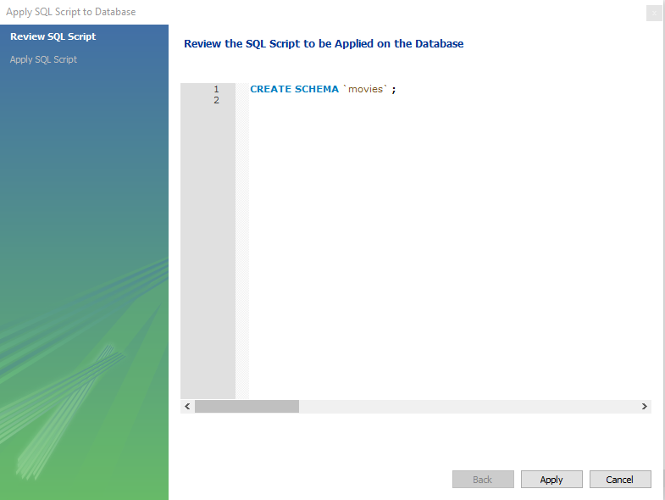

After I have a csv file as data sheet, I used workbench table data import wizard to add csv into database. For this reason, I did not use any script to create database. You can see the scripts that automatically used in the output section.

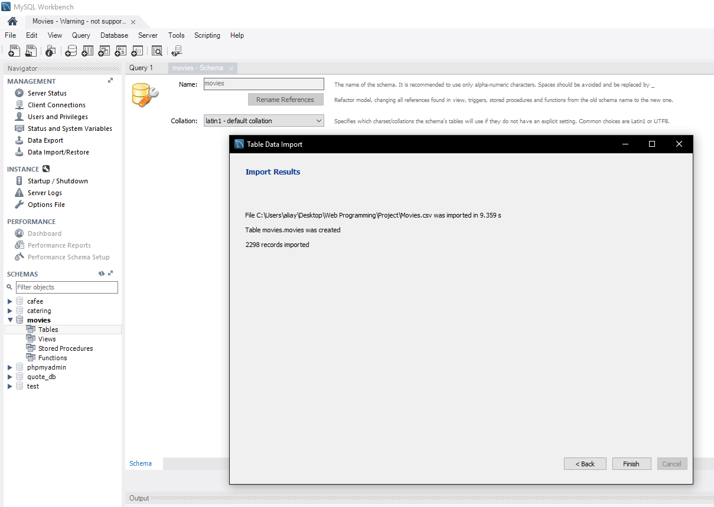



To see records we created, I used SELECT \* FROM `movies`.`movies`; script command;

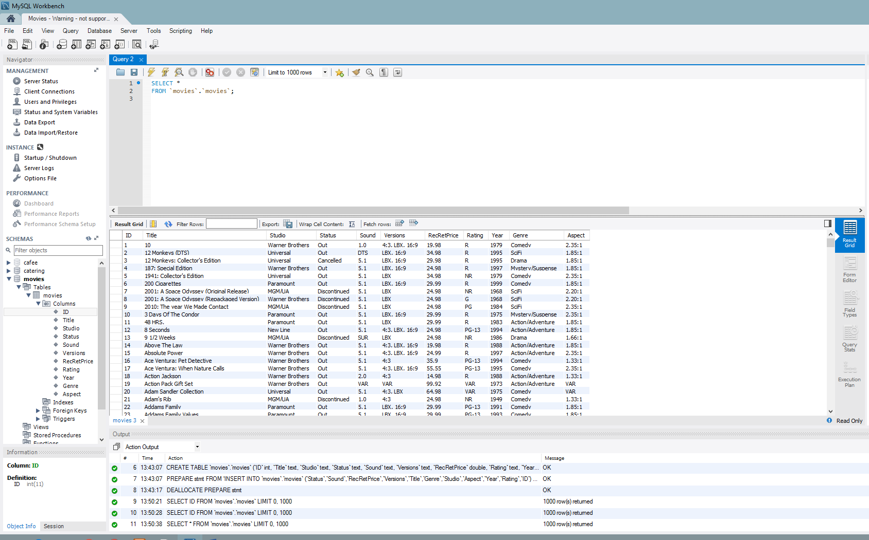

Address what develop and run environment are used, e.g. what tools will be used for design and development. How you will set up server-side environment and database base.

o Identify any ambiguity in the specifications and requirements, and clarify them before designing the application.

I am planning to use xammp application and MySQL Workbench application for develop and run environment. We need to have xammp and workbench installed and running in target computer. There are not any special requirements for this project.

Design the application

o Produce the prototype of the user interface in a visual format such as in images or template web site.

o Provide the database design, e.g. database structure.

o Save your design separately before developing the application.

Web Site Design:

I am planning to have four search areas (for Title, Genre, Rating and year) with one search button. Users can search any type of data from here.

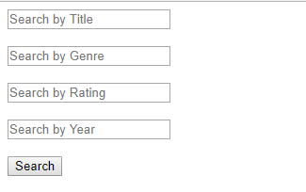

Database Design:

Database is going to have one table named movies. And 11 columns for each specification, ID, Title, Studio, Status, Sound, Versions, RecRetPrice, Rating, Year, Genre and Aspect.

